**Scheduler Final Report**

Wednesday, December 4, 2019

Georgia Gwinnett College

Software Development II

CyberATL

## Notes to the reader

This paper intends to document the requirements that has been successfully completed, as well as, those that still need to be developed. The second objective of this report is to expose the structure with which the team worked during 2019’s Fall semester.

This application is created with a MEAN model, meaning that, uses MongoDB, Express JS, Angular, and Node JS, latest versions to date. The project runs in port 4200 with node server or 500 with express server, however, If it is been launched for the first time it will be necessary to create or update package.json with “init” command. Currently, the MongoDB connection is stablished with CyberATL’s project manager account. This username and password examples need to be replaced for the new manager’s information under the Key.JS file. These primary instructions expectantly will allow another a new team to resume the project and become familiar with its structure.

## Detailed Business Requirements Recap

Type Key

R – Removed

TBD - To be done

C - Complete

**Authentication Subsystem**

| Number | Description | state |
| --- | --- | --- |
|  | Authenticate user | TBD |
|  | Differentiate between a professor or an administrator | C |
|  | Encrypt password | TBD |

Faculty subsystem

| Number | Description | Type |
| --- | --- | --- |
|  | Search for courses | TBD |
|  | Enroll courses | TBD |
|  | Drop courses | TBD |
|  | The system will prevent any hour incompatibility  between classes already enrolled | TBD |
|  | The system will display a schedule form where professor can clearly see what classes they have signed up | TBD |
|  | Allow the professors to send a section opening request on the professor’s perspective | TBD |
|  | The system will keep track of the credits hours that a professor is teaching | TBD |

Administration Subsystem

|  |  |  |
| --- | --- | --- |
|  | The System will filter courses | C |
|  | The System will filter courses sections of a specific course | C |
|  | Upload xlsx file | C |
|  | Convert xlsx file into Json | C |
|  | Replace database every semester | TBD |
|  | Display a list of professors interested on the section | TBD |
|  | Administrator can override any schedule changes and supersede the overall schedule | TBD |
|  | Count the number of credit hours a professor has enrolled | TBD |

**Known issues**

Issue 1: The database connection is stablished with Mongoose; however, the schema still needs to be concatenated with its respective angular component

Issue 2: The upload button converts xlsx files into Json files but still need to replace old files in Mongo database

Issue 3: Currently, the system has a button for each role, instead, the authentication algorithm should identify each roll.

Issue 4: Faculty subsystem needs to be completed

Issue 5: Course section details need to be displayed with a link to a page or pop up window

Issue 6: Identification of conflicts with red color feature is missing

**Multimedia**

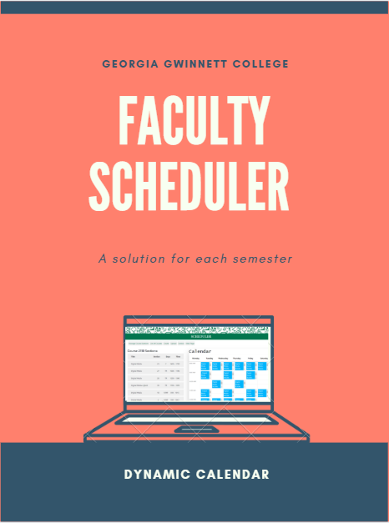

* **Flyer:**

Scheduler cover page

version Fall19.

* **Pictures**

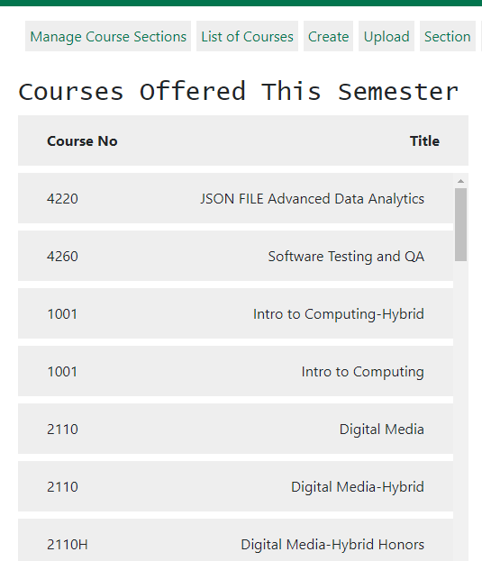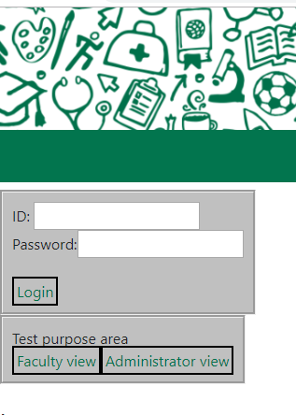

Figure 2 Courses list

Figure 1 Login Form

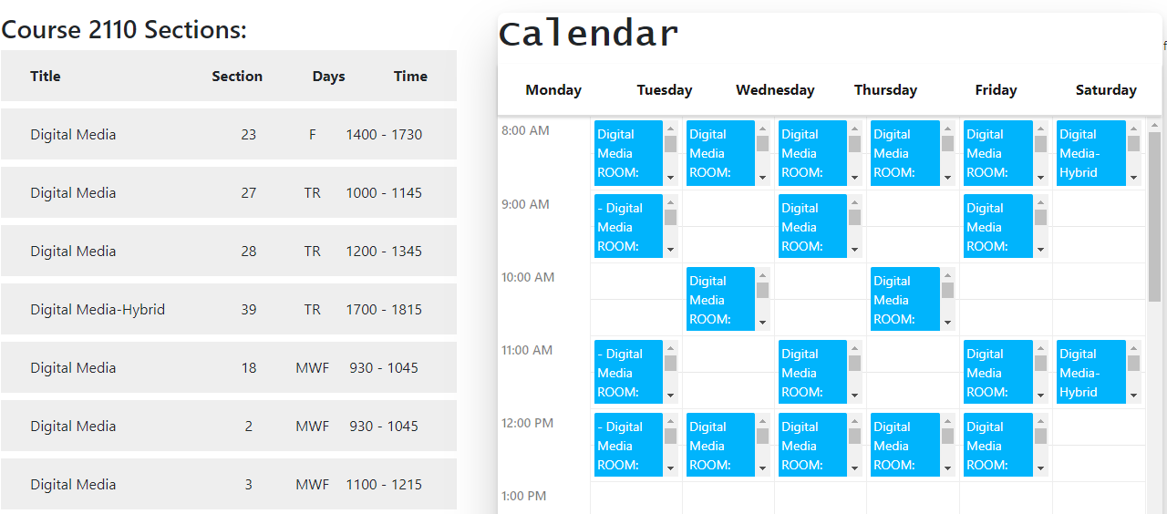

Figure 3 Course Section view

* **Video:**

[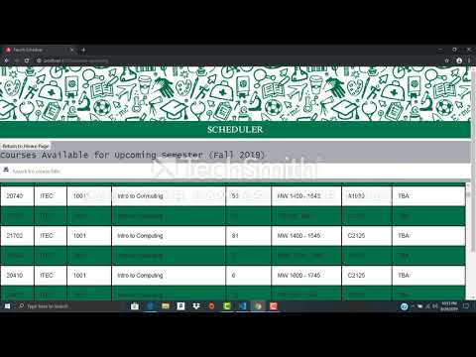](https://www.youtube.com/watch?v=b9XO8Hwmnz4)

Link: <https://www.youtube.com/watch?v=b9XO8Hwmnz4&t=4s>

**CyberATL Team Members**



1. **Sebastian Perez** - Testing Lead & Project Manager
2. **Terrance Perry** - Documentation Lead & Client Liaison
3. **Victor Akinla** - Lead Programmer & Data Modeler

**Client**

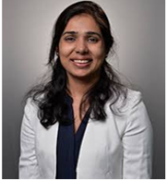

**Sonal S. Dekhane**

Professor at GGC and participant of International Conference on Data Mining (DMIN), and International Conference on Frontiers in Education.

She is currently in charge of the section’s distribution in the Information Technology Department

* **Where to find:**

**Repository**

<https://github.com/GGC-SD/Scheduler-ThunderCats>

**Documentation**

<https://github.com/GGC-SD/Scheduler-ThunderCats/tree/master/doc>

**License**

<https://github.com/GGC-SD/Scheduler-ThunderCats/blob/master/doc/Intellectual%20Property%20Agreement%20Draft.docx>